**GGS COLLEGE WEBSITE**

**Chapter:-1**

**About the Company**

**1.1 COMPANY PROFILE:**



INFOWIZ Technologies is among the leading companies in India providing Mobile Application Development Services, Web Application Development Services, Web Enterprise Application Services, Web Design & Redesign Services, Ecommerce online shopping systems Services. Since then, we have an edge over other entrepreneurs with our best services and goal centred approach.

INFOWIZ is an ISO certified US based company. It has been working from more than 5 years in the field of IT and Web Development and has been providing its clients with its exceptional and quality Web Design, Development and SEO services. Our clients range from individuals to professionals and small, medium and large scaled Businesses. In 2008, INFOWIZ entered into IT outsourcing and partnered successfully with many offshore web and SEO companies of US, UK, France, Ireland, Canada, and Australia etc. to provide them quality and timely services.

INFOWIZ does not boost itself of being the best development company but automatically enjoys reputable position among top Web Development companies because we of our timely delivery and quality work. We don’t claim for something we can’t deliver. Before taking a project from a client, we ask for all his needs and requirements. After that our skilled team of professionals analyzes the needs and comes up with a plan as how we can work to completely satisfy those requirements of our clients. We then work step by step keeping our client informed about the progress and complete the project in time giving complete contentment to them.

From concept building to implementation of any project, our team manages the projects efficiently up to its completion. Our tactful strategy and dedication towards quality work has given us the recognition we enjoy and that is why our clients only come back to us whenever they require any kind of web related solutions. We do not only emphasize on formulating an attractive solution to our clients, but we believe in providing a workable solution. INFOWIZ is an organization which is established in the field of VLSI-VHDL, Embedded systems, PHP, .NET, Web Designing, Web Development, Network Support and Network training.

**Vision**

To enable our customers to respond faster and more intuitively to changing market dynamics, by delivering seamless solutions that add exponential value to their business – such that they take pride in ownership of Infowiz products, ensuring Infowiz becomes their ‘Natural Choice’ for repeat business.

**Mission**

We endeavor to delight customers through quality, performance and innovation, employing best-of-breed practices and technical wisdom to not only deliver “best-fit customized solutions and support” but also a complete collaborative business experience.

**Values**

Infowiz business values and shared standards are built around creating an environment of teamwork, fairness, security, integrity, dignity and respect, benefiting not only Clients, Stakeholders, Employees & Peers but also influencing the business environment we operate in. It is our firm belief that these objectives can only be achieved through mutual respect and cooperation.

**Achievements**

1. We are among the Top Five IT Solution providers at business to business portal.
2. We are among the well reputed organizations in the region.
3. We are being acknowledged for providing one of the best career opportunities in Punjab.
4. We have a strong global client base associated with us

**OUR HOTTEST CLIENTS & PROJECTS**

**PROJECTS COUNTRY URL’s**

1. Viva Sales www.[**infowiz.in/vivasales**](http://infowiz.in/vivasales)

UK

2. Mds Creative www.mdscreative.com

Germany

3. Liddle TV www.filmon.com

UK

4. Paradigms(Android) running

Australia

5. Printcost www.popgraphics.net

UK

6.PSTDOBootstrap www.bootstrap.achieversperfect.com

USA

7. Essencesoftwares www.essencesoftwares.com

Australia

8. Dashboard (Wordpress) running

USA

9. Realstate www.realestate.infowiz.in

Russia

10. Dealpartners (WordPress) www.dealpartners.co.uk.gridhosted.co.uk

UK

11. Littletonvineyard www.littletonvineyard.net

USA

12. Gpakoffshore www.gpakoffshore.com

UK

**OUR TEAM**

**“A Ship is as good as the crew who sail her**.**”**

Our Technical team of professionals handing, designing & delivering of projects has a strong presence in the North India & the US. Our engineers are already working on the latest technologies like **I-Phone & Android** Applications, **Robotics**, **VLSI-VHDL**, Embedded System, Networking and **Cloud computing.**

**1.** Dr. Seema

(**Managing Director**)

She is the backbone of INFOWIZ and a woman with more than 9 year rich practical experience who believes in taking up new ventures and projects.

**2.** Mr. Rajeev Nayyar

(**General Manager**)

A man who strongly feel that “Nothing is Impossible”. A very committed team leader who has been professionally attached with Multinational companies for more than 18 years and has lead the marketing teams in all states of North India.

**3.** Ms. Shagun

**(Center Head)**

A woman who believes that “Honour Time & Place, then you will be honoured.” She has more than 4 years solid industrial experience in a software companies & is very dashing and innovative in her technical approach.

**4.** Ms. Urvashi

**(Dean Academics)**

A woman who believes that “Challenges are what make life interesting and overcoming them is what makes life meaningful.” She has more than 3years experience in business development.

**5.** Mr. Gaurav Puri

**(Manager)**

A man believes that “don’t wait for extra ordinary opportunities, seize common

occasions and make them great.” He has more than 4 years’ experience in marketing field.

6. Er. Vishal Goyal

(**Head & Technical Advisor at US Branch**)

More than 10 years industrial experience in US and smooth handling of the entire US business.

**7.** Er. Yukti Jindal

(**Center Head- US Branch**)

A woman who firmly believes that “In life, where you reach largely depends upon where you start.” She joined this branch in the year 2007 and has given her immense inputs in bringing the company to its present status.

**COURSES OFFERED**

**For CSE/IT/MCA Professionals:-**

1. Web Development in PHP with LIVE Projects
2. Web Development in .NET with LIVE Projects
3. JAVA (Core as well as Advance ) with LIVE Projects
4. Android Applications with LIVE Projects
5. Web Designing (Photoshop, Coral Draw)
6. C#, Console Applications, VB.NET, ASP.NET
7. MySQL, SQL, ORACLE
8. Networking (MCSE, CCNA, RHSE)
9. SEO (Search Engine Optimization)

**For ECE/EE/EIE Professionals:-**

1. Robotics With Live Project
2. VLSI-VHDL with Live Project
3. Embedded System Design with Live Project
4. Microcontroller with Live Project
5. Microprocessor with Live Project
6. PCB Designing
7. AVR & PIC Family
8. PCB and layout designing
9. AUTOMATION with Live Project
10. Project development with ARM processors

Our core strength is our timely, technically and cost effective project delivery. We also provide customers with designs as per their demands. INFOWIZ also provide Industrial Training of 6 Months & 6 Weeks in IT & Electronics to B.Tech & MCA students. We help students in building their career.



**1.2 OVERVIEW OF PROJECT :**

This project **“college website**“ is used to provide information of the college. It provides us a simple interface for maintenance of student information and Staff information. It can be used by educational institutes or colleges to provide information of students easily. Achieving this objective is difficult using a manual system as the information is scattered, can be redundant and collecting relevant information may be very time consuming. All these problems are solved using this project.

This project performs a complete application of modest size that uses PHP, JavaScript and HTML to link a Tutorial with Database (MySQL). We have also one main administrator who can view, change, modify, active and deactivate the details of students and staff.

This project gives the great control to handle the college or any system in any organization that working as collage. Using this website we can simply share all information about our organization to all over the world.

The project is very useful for those who want to know about college. The project provides facilities like online registration and profile creation of students and staff thus reducing paperwork and automating the record generation process in an educational institution. This project also provides a facility to all teachers that they can upload date sheets and results students can view or downloads their date sheets and results. Students can also check their fees.

Throughout the project the focus has been on presenting information in an easy and intelligible manner.

**1.2.1 OBJECTIVES:**

* **Online registration of Students:** All the students are registered online. Firstly they fill an online registration form completely and correctly so that they are successfully registered here. The system provides facility to students to see different.
* **Online registration of staff: :** All the staff are registered online. Firstly they fill an online registration form completely and correctly so that they are successfully registered here. The system provides facility to staff to upload different.
* **Maintenance of Students/Staff records:** The proposed system aims at all the records of student and staffs very carefully managed in the database.
* **Managed Courses by Admin:** In the proposed system the administrator manages all the courses. He has a authority to add a new course, remove an existing record and edit an existing records.
* **Upload Result by Faculty:** The proposed system aims at all the staff members can upload result.
* **View/Download date sheets by Students:** The proposed system, it aims at the students can view or downloads their date sheets. Students can also view their results.

**1.2.2 BENEFITS:**

**Benefits for using the site should include:**

* Personal and Career information from a broad spectrum of B.Tech, MBA and MCA professionals.
* B.Tech, MBA and MCA course and other information from college.
* Timely and up to date information that encourages readers to return to the site.
* Call to action, and plans for students to follow to prepare for a B.Tech, MBA and MCA career.
* Daily activity and updates of college.

Two potential groups of viewers exist:

* Students interested in a B.Tech, MBA or MCA seeking more in-depth information about a College.
* Students that are in that college but are seeking for some information.
* Provide basic downloads for students of college and general information for viewer of website seeking for information of institute
* Information about other institutes of Sachdeva Group

**1.2.3 PROCEDURES:**

**About The Project:**

Website is aimed toward students who have completed their higher studies or graduation and are looking for a college for further studies. Using this website we can simply share all information about our organization to all over world.

The entire site handle by the administrator by using admin panel .Only one person can access the admin panel known as administrator that controls all the site form backend. In admin panel administrator can manipulate the entire site like (update the data shown on front end, delete the data, and modify the data). Administrator can add courses, delete courses and manipulate it. All the registered users information is shown in admin panel and administrator can easily manipulate it. You don’t need to go anywhere in the world just registered on there and access and know all the information about the organization. In this project every user (end user) has been assigned a unique Login Id and password to access his account and use the software. Organizations definitely will love this project.

**Modules:**

**Login module**:

Login module will help in authentication of user accounts. Users who have valid login id and password can only login into their respective accounts.

**Registration Module**:

This module will help the student and staff get registered from anywhere if internet is present .This module will really simplify the task of on paper registration.

**User Management**:

This module will help the administrator in enabling/disabling a user registration and account and updating user information as required.

The project has three panels namely:

1. Administrator Panel
2. Staff Panel
3. Student Panel

**Administrator Panel:**

This panel mainly handles the website. The entire site handle by the administrator by using admin panel .Only one person can access the admin panel known as administrator that controls all the site form backend. In admin panel administrator can manipulate the entire site like (update the data shown on front end, delete the data, and modify the data). All the registered users information is shown in admin panel and administrator can easily manipulate it.Those students that are newly registered only admin has an authority to active or deactivate their registration. If admin active their registration then only students are login and if admin deactivate their registration then their registration is deleted from the database. The main functions of this panel are view the records of students, view the records of staff members, read the feedback from users, add a new course and edit any existing course.

**Staff panel:**

Staff can login into the system and can perform various functions. A staff member can view his/her personal details and can edit into their account like change their password. A staff member can upload result for student and can upload date sheets. A staff member can view the result of any student. Only those staff members whose accounts are activated by the administrator can access their accounts.

**Student Panel:**

Students can login into the system and can perform various functions. A student can view his/her personal details and can edit into their account like change their password. A student can view or downloads their result that are uploaded by the teacher. A student can download only those result that are related to his branch. A student can download their date sheets and can view their results. Only those students whose accounts are activated by the administrator can access their accounts.

**Chapter:-2**

**SOFTWARE DEVELOPMENT LIFE CYCLE**

**2.1 WHAT IS SDLC? :**

The Systems Development Life Cycle **(SDLC) or** *Software Development Life cycle* is a conceptual model used in project management that describes the stages involved in an information system development project from an initial feasibility study through maintenance of the completed application. Various SDLC methodologies have been developed to guide the processes involved including the waterfall model (the original SDLC method). Documentation is crucial regardless of the type of model chosen or devised for any application, and is usually done in parallel with the development process. Some methods work better for specific types of projects, but in the final analysis, the most important factor for the success of a project may be how closely particular plan was followed.

**2.2 PHASES OF SDLC:**

The System Development Life Cycle framework provides a sequence of activities for system designers and developers to follow. It consists of a set of steps or phases in which each phase of the SDLC uses the result of the previous one.

A System Development Life Cycle (SDLC) adheres to important phases that are essential for developers, such as planning, analysis, design and implementation, and are explained in the section below. A number of System Development Life Cycle (SDLC) models have been created: Waterfall, fountain, spiral, build and fix rapid prototyping, incremental, and synchronize and stabilize. The oldest of these and the best known is the Waterfall model: A sequence of stages in which the output of each stage becomes the input for the next. These stages can be characterized and divided up in different ways, including the following:

* **Project Planning, Feasibility study:** Establishes a high-level view of the intended project and determines its goals.
* **System Analysis, Requirements definition:** Defines project goals into defined function and operation of the intended application. Analyzes end-user information needs.
* **System design:** Describes desired features and operations in detail, including screen layouts, business rules, process diagrams, pseudo code and other documentation.
* **Implementation:** The real code is written here.
* **Integration and Testing:** Brings all the pieces together into a special testing environment, then check for errors, bugs and interoperability.
* **Acceptance, Installation, Deployment:** The final stage of initial development, where the software is put into production and runs actual business.
* **Maintenance:** What happens during the rest of the software’s life changes, correction, additions, and move to a different computing platform and more? This, the least glamorous and perhaps most important step of all, goes on seemingly forever.

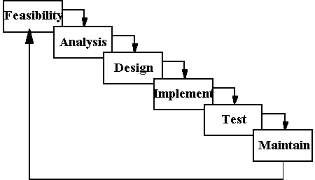

Figure 2.1 - System Development Life Cycle (SDLC) Phases

**Chapter-3**

**FEASIBILITY STUDY**

**3.1 WHAT IS FEASIBILITY STUDY?**

Feasibility study phase is where the project lifecycle begins. Feasibility study is an evaluation of a proposal designed to determine the difficulty in carrying out a designated task. Generally, a feasibility study precedes technical development and project implementation. In other words, a feasibility study is an evaluation or analysis of the potential impact of a proposed project.

Feasibility study is used to measure how the development of a system should be beneficial to organizations. Feasibility study should be performed throughout the development of the system. Feasibility study involves making a preliminary determination of end user needs and to determine the feasibility, that system is satisfied goal of project or not. The goal of feasibility study is to evaluate alternative system and to provide most feasible and desirable system for development.

A feasibility study should provide enough information to decide:

* Whether the project can be done?
* Whether the final system will benefit its intended users?
* What are the alternatives among which a solution will be chosen?
* Is there a preferred alternative?

The key considerations in feasibility analysis are:

* Technical feasibility
* Operational feasibility
* Economic feasibility

**3.1.1 TECHNICAL FEASIBILITY:**

This is concerned with specifying equipment and software and hardware that will successfully satisfy the user requirement. The technical needs of the system may vary considerably, but might include;

* The facility to produce output in a given time.
* Response time under certain conditions
* Ability to process a certain volume of transaction at a particular speed.
* Facility to communicate data to distant location.

In examining technical feasibility, configuration of the system is given more importance than the actual make of hardware. The configuration should give the complete picture about the system requirements. What speeds of input and output should be achieved at particular quality of printing.

According to the definition of technical feasibility the compatibility between front-end and back-end is very important. In our project the compatibility of both is very good. The degree of compatibility of JSP and SQL Server 2000 is very good. The speed of output is very good when we enter the data and click button then the response time is very fast and give result very quickset. I never find difficulty when we use complex query or heavy transaction. The speed of transaction is always smooth and constant. This software provides facility to communicate data to distant location.

At present scenario the no of backend are available but I have selected SQL Server 2000 because of the following number of reasons.

* + Able to handle large data.
  + Security.
  + Robust RDBMS.
  + Backup & recovery.

With the help of above support we remove defect of existing software. In future we can easily switch over any plate form. To ensure that system does not halt in case of undesired situation or events. Problem effected of any module does not affect any module of the system. A change of hardware does not produce problem.

**3.1.2 OPERATIONAL FEASIBILITY:**

It is a measure of how well a proposed system solves the problems, and takes advantage of the opportunities identified during scope definition and how it satisfies the requirements identified in the requirements analysis phase of system development.

During operational feasibility, it is determined whether the system will operate in the way that user wants or not. Operational feasibility must determines how the proposed system will fit in with the current operations and what, if any, job reconstruction and training will be needed to implement the system. It is a measure of how well the solutions of the problem or specific alternative solutions will work in the organizations. It deals with the operations performed within the network. The essential questions that help in testing the operational feasibility of a system are following:

* Does management support the project?
* Are the users not happy with current business practices? Will it reduce the time (operation) considerably? If yes, then they will welcome the change and the new system.
* Have the users been involved in the planning and development of the project? Early involvement reduces the probability of resistance towards the new system.
* Will the proposed system really benefit the organization? Does the overall response increase? Will accessibility of information be lost? Will the system effect the customers in considerable way
* What changes will be brought with the system?
* What organization structures are disturbed?

**3.1.3 ECONOMIC FEASIBILITY:**

Economical feasibility determines the cost and benefits of the proposed system and compare with the budget. The system that is made must also be economical. Economic analysis commonly known as cost/benefit analysis. The cost of the project includes the cost of hardware, software development and implementation. If benefits are found more than costs then the decision is made to design and implement the network. The cost should be consistent according to the operations being performed within the network.

Economic analysis is the most frequently used technique for evaluating the effectiveness of a proposed system. More commonly known as cost/benefit analysis; the procedure is to determine the benefits and saving that are expected from a proposed system and compare them with cost. If benefits outweigh cost, a decision is taken to design and implement the system. Otherwise, further justification or alternative in the proposed system will have to be made if it is to have a chance of being approved. This is an on-going effort that improves in accuracy at each phase of the system life cycle.

**Chapter-4**

**SYSTEM REQUIREMENT AND ANALYSIS**

**4.1S/W & H/W REQUIREMENT:**

This section describes the various hardware & software requirement by the developer during the development of project & the tools used. It also includes specification required by the client for implementing & using the system. This includes the decision about the operating system to be used. The alternatives are passed through the Mandatory requirements and screening criteria, which is a combination of the requirements and some implicit requirements that the alternative should satisfy.

# 4.1.1 Developing Desktop Requirement :

**4.1.1.1 Hardware:**

* Intel Pentium processor® at 2.66 GHz
* 256 MB RAM minimum, Recommended 512 MB Ram
* And other regular hardware devices

**4.1.1.2 Software:**

* PHP
* Java Script
* MySQL
* Apache server

**4.1.2 Software and Hardware Used for Client:**

* + - 1. **Software:**
* OS independent
* Internet browser

**4.1.2.2 Hardware:**

* + - Intel Pentium P III 450MHz or higher
    - 128 MB RAM, recommended 256 or MB higher and other regular hardware

devices

**4.1.3 Software and Hardware for Server:**

**4.1.3.1 Software:**

* + - Jdk1.5.0
    - JSP2.0
    - Microsoft SQL Server 20

4.1.3.2 Hardware:

* Intel Pentium IV ® at 2.66 GHz minimum, recommended 3.02 GHz
* 512 MB RAM minimum, Recommended 1 GB Ram
* And other regular hardware devices.

**4.2 SOFTWARE REQUIREMENT SPECIFICATION:**

The software requirement specification is produced at the culmination of the analysis task. The function and performance allocated to software as part of system engineering are refined by establishing a complete information description, a detailed functional description, a representation of system behavior, an indication of performance requirement and design constraints appropriate validation criteria, and other information pertinent to requirement.

The introduction to software requirement specification states the goals and objectives of the software, describing it in the context of the computer based system.

The Information Description provides a detailed description of the problem that the software must solve. Information content, flow and structure are documented..

A description of each function required to solve the problem is presented in the functional Description. Validation Criteria is probably the most important and ironically the most often neglected section of the software requirement specification.

**ELEMENTS OF ANALYSIS MODEL**

The analysis model must achieve three primary objectives:

* To describe what the customer requires
* To establish a basis for the creation of software design
* To define a set of requirements that can be validated once the software is built.

**4.3TECHNOLOGY USED :**

**4.3.1 Server Side Technologies:**

For server-side programming you will need a web server on your machine. This can be IIS on a Windows platform or something like Apache for other operating systems. Apache dominates the web server scene, currently powering 60% of the Web. In order to use the server-side scripting tool you will need to install and configure the PHP language in interpreter on your server.

* PHP.
* AJAX.

**4.3.2Client Side Technologies:**

* JavaScript.
* HTML.
* CSS.
* J-Query.

**4.3.3 Database used for these products:**

* MY SQL

**Brief Introduction about PHP**

PHP is server side scripting language. PHP begin as a PERSONAL HOME PAGE scripting tool. Today PHP is widely used in personal and corporate world as an efficient web development plate form. In most cases PHP is introduced in corporation because of its speed and absence of license fees.

1. Operators
2. Control statements
3. Mathematical functions etc.

**Features of practical PHP application.**

* An object oriented code base
* External HTML interface using template
* External configuration.
* Customizable message.
* Relational Data storage.
* Built in access control.
* Portable directory structure.

PHP acronym for (PHP Hypertext pre-processor) is a server side embedded scripting language. This means it works with an HTML document to confer to it the capacity of generating content on demand. You can convert your site into a web application, not just a collection of static pages which may not get updated quite so often, Which may be alright for the PERSONAL websites, but not for the one that is going to be used with business and educational websites.

**Use full web sites:-**

Here is some use full website which you can use to keep you update in PHP development, APACHE and MySQL.

1. www.php.net

2. http://www.phpbuilder.com

3. http://wwwApache.org

4. <http://www.mysql.com>

**Why PHP?**

The answer will be: simplicity, an almost natural way of using databases and platform independence.

It was open source?

Of course general scripting or programming languages like Perl, Python, etc. have also platform independence, and are open source. They are great languages, and sometimes overkill for what you need, like using a concert mixer to make scrambled eggs. PHP was designed to work on the web, and in this ambit it excels; connecting and querying a database is a simple task that can be handled in 2 or 3 lines of code. The PHP scripting engine is well optimized for the response times needed on web applications; it can even be part of the web server itself improving the throughput even more.

**Brief Introduction about JavaScript:**

JavaScript is a scripting language widely used for client-side web development. It was the originating dialect of the ECMA Script standard. It is a dynamic, weakly typed, prototype-based language with first-class functions. JavaScript was influenced by many languages and was designed to look like Java, but be easier for non-programmers to work with.

Although best known for its use in websites (as client-side JavaScript), JavaScript is also used to enable scripting access to objects embedded in other applications.

JavaScript, despite the name, is essentially unrelated to the Java Programming language, although both have the common C syntax, and JavaScript copies many Java names and naming conventions. The language’s name is the result of a co-marketing deal between Netscape and Sun, in exchange for Netscape bundling Sun’s Java runtime with their then-dominant browser. The key design principles within JavaScript are inherited from the Self and Scheme programming languages.

**Brief Introduction about HTML:**

HTML, an initialism of Hyper Text Markup Language, is the predominant Markup language for web pages. It provides a means to describe the structure of text-based information in a document by denoting certain text as links, headings, paragraphs, list, and so on and to supplement that text with interactive forms, embedded images, and other objects. HTML is written in the form of tags, surrounded by angle brackets. HTML can also describe, to some degree, the appearance and semantics of a document, and can include embedded scripting language code (such as JavaScript which can affect the behaviour of Web browsers and other HTML processors.

**Brief Introduction about Cascading Style Sheets:**

Cascading Style Sheets (CSS) is a style sheet language used to describe the presentation of a document written in a Markup language. Its most common applications are to style web pages written in HTML& XHTML, but the language can be applied to kind of XML document, including SVG & XUL.

CSS can be used locally by the readers of web pages to define colours, fonts, layout, and other aspects of document presentation. It is designed primarily to enable the separation of document content (written in CSS). This separation can improve content accessibility, provide more flexibility and control in the specification of presentation characteristics, and reduce complexity and repetition in the structural content (such as by allowing for table less web design). CSS can also allow the same Markup page to be presented in different styles for different rendering methods, such as on-screen, in print, by voice (when read out by a speech-based browser or screen reader) and on Braille-based, tactile devices. CSS specifies a priority scheme to determine which style rules apply if more than one rule matches against a particular element.

**Brief Introduction about AJAX:**

AJAX (Asynchronous JavaScript and XML), is a group of interrelated web development techniques used to create interactive web applications or rich Internet applications. With Ajax, web applications can retrieve data from the server asynchronously in the background without interfering with the display and behaviour of the existing page. The use of Ajax has led to an increase in interactive animation on web pages. Data is retrieved using the SMLHttpRequest object or through the use of Remote Scripting in browsers that do not support it. Despite the name, the use of JavaScript and XML is not actually required, nor do the requests need to be asynchronous. The acronym AJAX has thus changed to the term Ajax, Which does not represent these specific technologies.

The term Ajax has come to represent broad group web technologies that can be used to implement a web application that communicates with a servicer in the background, without interfering with the current state of the page. Jesse James Garrett explained that the following technologies are required:

* XHTML and CSS for presentation
* The Document Object Model for dynamic display of and interaction with data
* XML and XSLT for the interchange, manipulation and display of data, respectively.
* The XML Http Request object for asynchronous communication
* JavaScript to bring these technologies together.

Since then, however, there have been a number of developments in the technologies used in an Ajax application, and the definition of the term Ajax. In particular, it has been noted that.

* Java Script is not the only client-side scripting language that can be used for implementing an Ajax application. Other languages such as VBScript and EGL Programming Language are also capable of the required functionality.
* XML is not required for data interchange and therefore XSLT is not required for the manipulation of data. JavaScript Object Notation (JSON) is often used as an alternative format for data interchange, although other formats such as preformatted HTML or plain text can also be used.

**DATABASE:**

**Brief Introduction about MYSQL:**

MYSQL is a relational data base and it is a part of the solution of the LINUX open source evolution MYSQL was developed by TcX in 1996. They created it because they needed a relational database that could handle a large amount of data on cheap hardware.

MySQL is the fastest relational database now in market. If MySQL is the fastest and good why, it has not already caught the attention of industry. The answer is that until 1999, LINUX and the open source product was practically unknown. MYSQL primarily runs on UNIX based system, though there are ports for almost every plate forms in the market. Until the open source moment and the availability of UNIX based operating system at affordable price, no body looked at MYSQL as a contender.

Because of the popularity of Linux operating system MYSQL has grown in market which provided various users in market to use a relational data base language license free with many open source technology for development. as the PHP is an open source server side scripting language and use apache and Linux server to execute its content, here the MYSQL is a best relational database to use with open source PHP.

**Why MYSQL:-**

There are some points why to use MYSQL with PHP.

* It is COST-EFFECTIVE.
* It is QUICK and POWER FULL.
* It is improving all the time

T-SQL (Transact-SQL) is the primary means of programming and managing SQL Server. It exposes keywords for the operations that can be performed on SQL Server, including creating and altering database schemas, entering and editing data in the database as well as monitoring and managing the server itself. Client applications, both which consume data or manage the server, leverage SQL Server functionality by sending T-SQL queries and statements which are then processed by the server and results (or errors) returned to the client application

**MySQL is a Microsoft Product.**

* + This is not case sensitive.
  + F5 is used to execute query

**There are 2 types of statements in MY SQL.**

* + MySQL DDL statement
  + MySQL DML Statement

**DDL Statement**

DDL stands for Data Definition Language. It includes following commands:

* + Create database
  + Drop database
  + Create Table
  + Alter Table
  + Drop Table

**DML Statement**

DML stands for Data Manipulation Language. It includes following commands:

* + Select
  + Insert into
  + Update
  + Delete

**Joins**

Joins are used to combine 2 or more tables.

Types of Joins:

* Inner join
* Left join
* Right join
* Full outer join

**Temporary Table**

Temporary tables are similar to views but temporary tables have physical existence. When we drop table, Temporary table also gets dropped.

**SQL Functions**

Functions are of following types:

* Aggregate functions
* Scalar functions

**WAMP SERVER:-**

WAMP server is powered by zend corporation. The server helpful for executing the PHP server side script following are the version and configuration information of WAMP server.

**4.4 SYSTEM ANALYSIS:**

Analysis is the detailed study of the various operation performed by the system and their relationship within and outside the system. While developing project many problems arises. To solve those problems data is collected from manuals, books, generals etc. Logical system models and tools are used e.g.: DFD, Interviews, Data Dictionary etc. The requirements gathering process is intensified and focused specifically on software. To understand the nature of the program(s) to be built, the software engineer (“analyst”) must understand the information domain for the software, as well as required function, behaviour, performance, and interfacing. Requirements for both the system and the software are documented and reviewed with the customer.

Requirement analysis enables the system engineer to specify function and performance, indicate software’s interface with other system elements, and establish constraints that software must meet, Requirements allow the software engineer (often called analyst in this role) to refine the software are allocation and build modules of the data, functional, and behavioural domains that will be treated by software, Analysis provides the software designer with models that can be translated in to data, architectural, interface, and procedural design. Finally, the requirement specification provides the developer and the customer with the means to assess quality once software is built. Developer and the customer with the analysis may be divided into five areas of effort:

* Problem Recognition
* Evaluation and Synthesis
* Modeling
* Specification
* Review

**Chapter-5**

**SYSTEM DESIGN PHASE**

**5.1 MEANING OF SYSTEM DESIGN:**

System design is the process of developing specifications for a candidate system that meet the criteria established in the system analysis. Major step in system design is the preparation of the input forms and the output reports in a form applicable to the user.

**Design objectives:**

The primary objective of the design is to deliver the requirements as specified in the feasibility report. These are the some of the objectives.

* **Practicality:** The system is quite stable and can be operated by the people with average intelligence.
* **Efficiency:** I tried to involve accuracy, timeliness and comprehensiveness of the system output.
* **Cost:** It is desirable to aim for the system with a minimum cost subject to the condition that it must satisfy the entire requirement.
* **Flexibility:** I have tried that the system should be modifiable depending on the changing needs of the user. Such modifications should entail extensive reconstructing or recreation of software. It should also be portable to different computer systems.
* **Security:** This is very important aspect which I followed in this designing phase and tried to covers the areas of hardware reliability, fallback procedures, and physical security of data.

The main objective of the system design is to make the system user friendly; system design involves various stages as:

* Data Entry
* Data Correction
* Data Deletion
* Processing
* Sorting and Indexing

System design is the creative act of invention, developing new inputs, a database, offline files, procedures and output for processing business to meet an organization objective. System design builds information gathered during the system analysis.

**WELL DEFINED SYSTEM**

In design an efficient and effective system is of great importance to consider the human factor and equipment that these will require to use. System analyst must evaluate the capabilities and limitations of the personal and corresponding factors of the equipment itself.

The characteristics associated with effective system operations are:

* Accessibility
* Decision Making Ability
* Economy
* Flexibility
* Reliability
* Simplicity

Success is a new system pivots on its acceptance or non-acceptance by the organization.

**For design of the website project**:

* First Database has to be designed which can be used to handle all the requirements of the users.
* The basic structure of the website has to be designed.
* The main template to be used for the website is designed.
* Some basic forms used in the website are designed and main interactions between the web pages and the direction of the flow of data are decided to be used further into the website project.

**5.2 Data Flow Diagrams:**

**DFD for admin:**

Remove course

Add courses

New registered student/staff records

Students’ record

Edit courses

Staff record

**Figure: 5.2.1**

**DFD for staff:**

**Figure: 5.2.2**

**DFD for student:**

**Figure: 5.2.3**

**5.3 FLOWCHART For admin**

Facilities

Contact us

Training & placement

Login

About us

Our courses

Is

Successful

?

View courses

View records

View faculty

View feedback

Remove course

Edit course

Reply

Remove

Staff records

Student records

View course info

Add course

No

Yes

Add as staff

Add as student

New registered students/staff

Active/deactive

**Figure: 5.3.1**

**5.4 DATABASE DESIGN:**

The overall objective in the development of the database technology has been to treat data as an organizational resource and as an integrated whole Database management system allows data to be protected and organize separately from other resources. Database is an integrated collection of data. The organization of data in the database aims to achieve free major objectives:

* Data Integration
* Data Integrity
* Data Independence

The Database is implemented using a DBMS package. Each particular DBMS has unique characteristics and general techniques for Database Design.

The proposed Management Information System stores the information relevant for processing in the Microsoft SQL Server Database. This MS SQL Server contains tables, where each table is called a field or column. A table also contains records which is a set of fields. All records, in a table the same set of fields with different information. Each table contains key fields that establish relationships in a MS SQL server database and how the records are stored. There are primary key fields that uniquely identify a record in a table. There are also fields that contain the primary key from another table called foreign keys.

Eventually, the programmer will incorporate the source code into the various programs, thus assuring consistency and simplifying the coding process. The databases have been designed in such a way that there is no duplication of information and loss of information.

**Chapter-6**

**Coding**

**CODING:**

The input to the Design Phase is the design document. During the coding phase, different modules identified in the design document are coded according to the module specifications. The Objective of the coding phase is to transform the design of the system, as given by its module specifications, into a high level languages and code and then unit this code. Software developers adhere to some well-defined and standard style of coding called coding standards. The reasons for adhering to a standard coding style are the following.

It gives a uniform appearance to the codes written by different engineers.

It encourages good programming practices.

It encourages code understanding.

**Coding Standards:**

* Rules for limiting the use of global.
* Content of the headers preceding codes for different modules.
* Errors return conventions and exception handling mechanisms.

**Code Walk-Through:**

It is an Informal technique for analysis of the code. A code walk through of a module is undertaken after the coding of the module is complete. Here, after a module has been coded, members of the development team selects some test cases and simulates execution of the by hand.

**Code Inspections:**

They aim explicitly at the discovery of commonly made errors. During which, the code is examined for the presence of certain kinds of errors, in contrast to the hand simulation on code execution as done in code walk-through.

**Index.php**

<?php

include("header.php");

?>

<div class="wrapper row3">

<div class="rounded">

<main class="container clear">

<div class="group btmspace-30">

<!-- Left Column -->

<div class="one_quarter first">

<ul class="nospace">

<li class="btmspace-15"><a href="ggs.php"><em class="heading">GGS CAMPUS</em> <img class="borderedbox" src="images/demo/sachdeva.jpg" alt=""></a></li>

<li class="btmspace-15"><a href="sachdeva.php"><em class="heading">SACHDEVA CAMPUS</em> <img class="borderedbox" src="images/demo/sach.png" alt=""></a></li>

<li class="btmspace-15"><a href="pharma.php"><em class="heading">PHARMACY CAMPUS</em> <img class="borderedbox" src="images/demo/pharmacy.png" alt=""></a></li>

<li><a href="poly.php"><em class="heading">POLYTECHNIC CAMPUS</em> <img class="borderedbox" src="images/demo/poly.jpg" alt=""></a></li>

</ul>

</div>

<!-- / Left Column -->

<!-- Middle Column -->

<div class="one_half">

<h2 align="center"><font color="blue">LATEST NEWS &amp; EVENTS</font></h2>

<?php

include("connect.php");

$r=mysql_query("select * from notice")or die(mysql_error());

if(mysql_num_rows($r)>0)

{

while($s=mysql_fetch_array($r))

{

?

<ul class="nospace listing">

<li class="clear">

<div class="imgl borderedbox"><img src="<?php echo $s['image']?>"></div>

<h1 class="nospace btmspace-15"><?php echo $s['notice'] ?></h1>

<p><font color="black"> <?php echo $s['title'] ?></p>

<p align="justify"><?php echo $s['type'] ?> </p></font>

</li>

</ul>

<?php

}

}

?>

</div>

<!-- / Middle Column -->

<!-- Right Column -->

<div class="one_quarter sidebar">

<div class="sdb_holder">

<h6><font color="blue">OUR TOP RECRUITERS</font></h6>

<ul class="nospace quickinfo">

<marquee behavior="slide" direction="down" height="510"> <li class="clear"><a href="hp.php"><img src="images/demo/hp.jpg">Hewlett-Packard Company </a></li>

<li class="clear"><a href="ibm.php"><img src="images/demo/ibm.jpg" alt="">IBM </a></li>

<li class="clear"><a href="infosys.php"><img src="images/demo/infosys.jpg" alt=""> Infosys</a></li>

<li class="clear"><a href="wipro.php"><img src="images/demo/wipro.jpg" alt="">wipro </a></li>

<li class="clear"><a href="tm.php"><img src="images/demo/tm.jpg" alt="">Tech Mahindra</a></li></marquee>

</ul>

</div>

<!-- / Right Column -->

</div>

</div>

<div id="twitter" class="group btmspace-30">

<div class="one_quarter first center"><a href="twitter.php"><i class="fa fa-twitter fa-3x"></i><br>

Follow Us On Twitter</a></div>

<div class="three_quarter bold">

<p>Inteligula congue id elis donec sce sagittis intes id laoreet aenean. Massawisi condisse leo sem ac tincidunt nibh quis dui fauctor et donecnibh elis velit <a href="#">@name</a> - 10:15 AM yesterday</p>

</div>

</div>

<! -- / main body -->

<div class="clear"></div>

</main>

</div>

</div>

<?php

include("footer.php");

?>

<div class="wrapper row5">

<div id="copyright" class="clear">

<p class="fl_left">Copyright &copy; 2015 - All Rights Reserved - <a href="#">Domain Name</a></p>

<p class="fl_right">Template by <a target="_blank" href="http://www.os-templates.com/" title="Free Website Templates">OS Templates</a></p>

</div>

</div>

<!-- JAVASCRIPTS -->

<script src="layout/scripts/jquery.min.js"></script>

<script src="layout/scripts/jquery.fitvids.min.js"></script>

<script src="layout/scripts/jquery.mobilemenu.js"></script>

<script src="layout/scripts/tabslet/jquery.tabslet.min.js"></script>

</body>

</html>

**Stulogin.php**

<?php

include("header.php");

?>

<div class="wrapper row3">

<div class="rounded">

<main class="container clear">

<div class="group btmspace-30">

<!-- Left Column -->

<div class="one_quarter first">

<ul class="nospace">

<h2 align="center"><font color="blue" size="4"> Student</font></h2>

<img src="images/demo/05.jpg">

</ul>

</div>

<!-- / Left Column -->

<!-- Middle Column -->

<?php

if(isset($_REQUEST['a']) && $_REQUEST['a']==1)

{

echo"<script>alert('Your account Is not active')</script>";

}

if(isset($_REQUEST['a']) && $_REQUEST['a']==2)

{

echo"<script>alert('Username and password is not match')</script>";

}

?>

<div class="one_half">

<h2 align="center"><font color="blue">Student Login Here</font></font></font></h2>

<table border="5" >

<form action="session.php" method="post">

<tr><th>email-id</th><th><input type="text" name="t1" style="color:black";/></th></tr>

<tr><th>password</th><th><input type="password" name="t2" placeholder="********" style="color:black";/></th></tr>

<tr><th colspan="2" align="center"><font color="gray"><input type="submit" value="Login"/>

</font></th></tr>

</form></table>

<p align="justify"><font color="purple"><img src="images/demo/03.jpg"/>When done, always log out of the website via the

"Log Out" link and be sure to close all copies of your browser. Closing the browsers will help to ensure the security of your account.</font> </p>

</div>

<!-- / Middle Column -->

<!-- Right Column -->

<div class="one_quarter sidebar">

<div class="sdb_holder">

<h2 align="center"><font color="blue">Our Mission</font></font></font></h2>

<table border="2">

<tr><th align="justify">-To facilitate the pursuit of academic excellence.</th></tr>

<tr><th align="justify">-To harness students' potential for extra-curricular and co-curricular activities.</th></tr>

<tr><th align="justify">-To foster in students a commitment towards society and the nation.</th></tr>

</table>

</div>

</div>

</div>

<!-- / Right Column -->

</div>

<div id="twitter" class="group btmspace-30">

<div class="one_quarter first center"><a href="twitter.php"><i class="fa fa-twitter fa-3x"></i><br>

Follow Us On Twitter</a></div>

<div class="three_quarter bold">

<p>Inteligula congue id elis donec sce sagittis intes id laoreet aenean. Massawisi condisse leo sem ac tincidunt nibh quis dui fauctor et donecnibh elis velit <a href="#">@name</a> - 10:15 AM yesterday</p>

</div>

</div>

<!-- / main body -->

<div class="clear"></div>

</main>

</div>

</div>

<?php

include("footer.php");

?>

<div class="wrapper row5">

<div id="copyright" class="clear">

<p class="fl_left">Copyright &copy; 2015 - All Rights Reserved - <a href="#">Domain Name</a></p>

<p class="fl_right">Template by <a target="_blank" href="http://www.os-templates.com/" title="Free Website Templates">OS Templates</a></p>

</div>

</div>

<!-- JAVASCRIPTS -->

<script src="layout/scripts/jquery.min.js"></script>

<script src="layout/scripts/jquery.fitvids.min.js"></script>

<script src="layout/scripts/jquery.mobilemenu.js"></script>

<script src="layout/scripts/tabslet/jquery.tabslet.min.js"></script>

</body>

</html>

**Session.php**

<?php

session_start();

echo $a=$_POST['t1'];

echo $b=$_POST['t2'];

if($a=="admin" and $b=="admin")

{

$_SESSION['admin']=$a;

header("location:admin2.php");

}

else

{

mysql_connect("localhost","root","")

or die(mysql_error());

mysql_select_db("batch")

or die(mysql_error());

$r=mysql_query("select * from clg where email_id='$a' and password='$b'")

or die(mysql_error());

if(mysql_num_rows($r)>0)

{

if($s=mysql_fetch_array($r)){

if($s['action']=="active")

{

$_SESSION['student']=$a;

header("location:student.php");

}

else

{

header("location:stulogin.php?a=1");

}

}

}

else

{

header("location:stulogin.php?a=2");

}

}

?>

**Contact.php**

<?php

include("header.php");

?>

<div class="wrapper row3">

<div class="rounded">

<main class="container clear">

<div class="group btmspace-30">

<!-- Left Column -->

<div class="one_quarter first">

<ul class="nospace">

<h2 align="center"><font color="blue" size="4">Contact Address</font></h2>

<font color="black">

<marquee direction="down" behavior="slide" height="170">

<li>GGS College of Modern Technology</li>

<li>Chandigarh-Ludhiana Highway</li>

<li>Kharar - 140 301, Punjab </li>

<li>Phone: +91-160-5001212</li>

<li>Email: ggs@ggssachdeva.com</li>

<li>Website: http://www.ggssachdeva.com</li> </marquee></font>

</ul>

</div>

<!-- / Left Column -->

<!-- Middle Column -->

<div class="one_half">

<h2 align="center"><font color="blue" size="4">Contact Us</font></h2>

<table>

<head>

<script>

function val()

{

flag=true;

var a=document.f.t1.value;

var b=document.f.t2.value;

var c=document.f.t3.value;

var d=document.f.t4.value;

if(a=="" &&b=="" &&c=="" &&d=="")

{

alert("full form is blank");

flag=false;

}

else

{

alert("your data is submitted");

flag=false;

}

return flag;

}

</script>

</head>

<form action="contactus.php" name="f" method="post" onsubmit="return val()">

<tr><th>Name</th><th><font color="gray"><input type="text" name="t1"></font></th></tr>

<tr><th>Email</th><th><font color="gray"><input type="text" name="t2"></font></th></tr>

<tr><th>Subject</th><th><font color="gray"><input type="text" name="t3"></font></th></tr>

<tr><th>Message</th><th><font color="gray"><textarea name="t4"></textarea></font></th></tr>

<tr><th colspan="2" align="center"><font color="gray"><input type="submit" value="submit"/></font></th></tr>

</form>

</table>

</div>

<!-- / Middle Column -->

<!-- Right Column -->

<div class="one_quarter sidebar">

<div class="sdb_holder">

<h6 align="center"><font color="blue">Location</font></h6>

<img src="images/demo/vt.png"/>

</div>

<!-- / Right Column -->

</div>

<div id="twitter" class="group btmspace-30">

<div class="one_quarter first center"><a href="twitter.php"><i class="fa fa-twitter fa-3x"></i><br>

Follow Us On Twitter</a></div>

<div class="three_quarter bold">

<p>Inteligula congue id elis donec sce sagittis intes id laoreet aenean. Massawisi condisse leo sem ac tincidunt nibh quis dui fauctor et donecnibh elis velit <a href="#">@name</a> - 10:15 AM yesterday</p>

</div>

</div>

<!-- / main body -->

<div class="clear"></div>

</main>

</div>

</div>

<?php

include("footer.php");

?>

<div class="wrapper row5">

<div id="copyright" class="clear">

<p class="fl_left">Copyright &copy; 2015 - All Rights Reserved - <a href="#">Domain Name</a></p>

<p class="fl_right">Template by <a target="_blank" href="http://www.os-templates.com/" title="Free Website Templates">OS Templates</a></p>

</div>

</div>

<!-- JAVASCRIPTS -->

<script src="layout/scripts/jquery.min.js"></script>

<script src="layout/scripts/jquery.fitvids.min.js"></script>

<script src="layout/scripts/jquery.mobilemenu.js"></script>

<script src="layout/scripts/tabslet/jquery.tabslet.min.js"></script>

</body>

</html>

**Chapter-7**

**Testing**

**7.1MEANING OF TESTING:**

Testing is the process of detecting errors. Testing performs a very critical role for quality assurance and for ensuring the reliability of software. The results of testing are used later on during maintenance also.

**Psychology of Testing:**

The aim of testing is often to demonstrate that a program works by showing that is has no errors. The basic purpose of testing phase is to detect the errors that may be present in the program. Hence one should not start testing with the intent of showing that a program works, but the intent should be to show that a program doesn’t work. Testing is the process of executing ap program with the intent of finding errors.

**7.2 Testing Objectives:**

The main objective of testing is to uncover a host of errors, systematically and with minimum effort and time. Stating formally, we can say.

* Testing is a process of executing a program with the intent of finding an error.
* A successful test is one that uncovers an as yet undiscovered error.
* A good test case is one that has a high probability of finding error, if it exists.
* The tests are inadequate to detect possibly present errors.
* The software more or less confirms to the quality and reliable standards.

**7.3 TYPES OF TESTING:**

**System Testing:**

In this phase the website is tested. Normally programs are written as a series of individual modules, these subjects to separate and detailed test. The site is then tested as a whole. The separate modules are brought together and tested as a complete site. The website is tested to ensure that interfaces between modules work (integration testing), the system works on the intended platform and with the expected volume of data (volume testing) and that the system does what the user requires (acceptance/beta testing).

A software test program should aim at detecting maximum number of errors in the site. The process of testing involves creating the test cases and implementing those test cases on the website to detect errors. The Testing Strategy and plan TSP document is a formal document that contains the test plan and the list of all types of test to be done on the software

Test Plan consists of the components to be tested, people involved in testing, test cases and the acceptance criterion for the software. Some guidelines to be followed while creating test plan are as follows:

The test planned for the software should be such that they detect the deviation of the software from client requirements. The test planned in the test plan should begin from smaller module and move to cover the entire system.

The test plan should assign the task of testing to a third person. This is because a person from outside the development team has the better chances of detecting errors. Software testing can be broadly classified into two categories:

* White Box Testing
* Black Box Testing

A testing strategy describes the steps that are performed during the testing of software.

* Unit Testing
* Integration Testing
* System Testing
* Functional Testing

The testing phase requires organizations to complete various tests to ensure the accuracy of programmed code, the inclusion of expected functionality, and the interoperability of applications and other network components. Thorough testing is critical to ensuring systems meet organizational and end-user requirements. Test plans created during initial project phases enhance an organization’s ability to create detailed tests. A bottom-up approach tests smaller components first and progressively adds and tests additional components and systems. A top-down approach first tests major components and connections and progressively tests smaller components and connections. Bottom-up tests often begin with functional (requirements based) testing. Functional tests should ensure that expected functional, security, and internal control features are present and operating properly. Testers then complete integration and end-to-end testing to ensure application and system components interact properly. Users then conduct acceptance tests to ensure systems meet defined acceptance criteria. Organizations should review and complete user, operator, and maintenance manuals during the testing phase. Additionally, they should finalize conversion, implementation, and training plans.

**For testing of the website:**

* All the features of the website are tested by running each function available in the website.
* The results of the tests conducted on the website are analyzed properly.
* Only after getting satisfactory results of testing the website can be uploaded on the network i.e. internet.

**Software testing:**

Software testing is the process used to measure the [quality](http://en.wikipedia.org/wiki/Software_quality) of developed [computer software](http://en.wikipedia.org/wiki/Computer_software). Usually, quality is constrained to such topics as [correctness](http://en.wikipedia.org/wiki/Correctness), completeness, [security](http://en.wikipedia.org/wiki/Computer_security_audit), but can also include more technical requirements as described under the [ISO](http://en.wikipedia.org/wiki/International_Organization_for_Standardization) standard [ISO 9126](http://en.wikipedia.org/wiki/ISO_9126), such as capability, [reliability](http://en.wikipedia.org/wiki/Reliability), [efficiency](http://en.wikipedia.org/wiki/Algorithmic_efficiency), [portability](http://en.wikipedia.org/wiki/Porting), [maintainability](http://en.wikipedia.org/wiki/Maintainability), compatibility, and [usability](http://en.wikipedia.org/wiki/Usability). Testing is a process of technical investigation, performed on behalf of stakeholders, that is intended to reveal quality-related information about the product with respect to the context in which it is intended to operate .

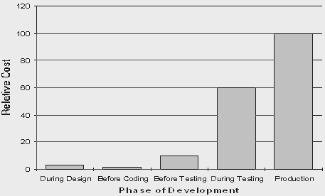

**White box, black box, and grey box testing:**

[White box](http://en.wikipedia.org/wiki/White_box_testing) and [black box testing](http://en.wikipedia.org/wiki/Black_box_testing) are terms used to describe the point of view that a test engineer takes when designing test cases. **Black box** testing treats the software as a black-box without any understanding as to how the internals behave. Thus, the tester inputs data and only sees the output from the test object. This level of testing usually requires thorough test cases to be provided to the tester who then can simply verify that for a given input, the output value (or behaviour), is the same as the expected value specified in the test case.

**White box** testing, however, is when the tester has access to the internal data structures, code, and algorithms. For this reason, [unit testing](http://en.wikipedia.org/wiki/Unit_testing) and debugging can be classified as white-box testing and it usually requires writing code, or at a minimum, stepping through it, and thus requires more skill than the black-box tester. If the software in test is an interface or API of any sort, white-box testing is almost always required.

In recent years the term [grey box testing](http://en.wikipedia.org/wiki/Grey_box_testing) has come into common usage. This involves having access to internal data structures and algorithms for purposes of designing the test cases, but testing at the user, or black-box level. Manipulating input data and formatting output do not qualify as grey-box because the input and output are clearly outside of the black-box we are calling the software under test. This is particularly important when conducting [integration testing](http://en.wikipedia.org/wiki/Integration_testing) between two modules of code written by two different developers, where only the interfaces are exposed for test.

**Grey box testing** could be used in the context of testing a client-server environment when the tester has control over the input, inspects the value in a SQL database, and the output value, and then compares all three (the input, sql value, and output), to determine if the data got corrupt on the database insertion or retrieval.

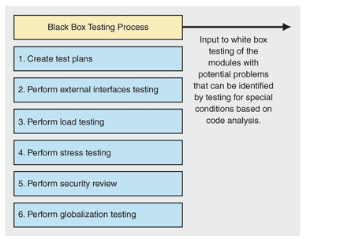

**Verification and validation:**

Software testing is used in association with [verification and validation](http://en.wikipedia.org/wiki/Verification_and_Validation) (V&V). *Verification* is the checking of or testing of items, including software, for conformance and consistency with an associated specification. Software testing is just one kind of verification, which also uses techniques such as reviews, inspections, and walkthroughs. *Validation* is the process of checking what has been specified is what the user actually wanted.

* **Verification**: Have we built the software right? (i.e. does it match the specification).
* **Validation**: Have we built the right software? (i.e. Is this what the customer wants?)

**Levels of testing:**

[**Unit testing**](http://en.wikipedia.org/wiki/Unit_testing):

It tests the minimal software component, or module. Each unit (basic component) of the software is tested to verify that the detailed design for the unit has been correctly implemented. In an Object-oriented environment, this is usually at the class level, and the minimal unit tests include the constructors and destructors.

[**Integration testing**](http://en.wikipedia.org/wiki/Integration_testing) :

It exposes defects in the interfaces and interaction between integrated components (modules). Progressively larger groups of tested software components corresponding to elements of the architectural design are integrated and tested until the software works as a system.

[**Functional testing**](http://en.wikipedia.org/wiki/Functional_testing):

It tests at any level (class, module, interface, or system) for proper functionality as defined in the specification.

[**System testing**](http://en.wikipedia.org/wiki/System_testing):

It tests a completely integrated system to verify that it meets its requirements.

[**System integration testing**](http://en.wikipedia.org/wiki/System_integration_testing) **:**

Itverifies that a system is integrated to any external or third party systems defined in the system requirements.

[**Acceptance testing**](http://en.wikipedia.org/wiki/Acceptance_testing) **:**

It can be conducted by the end-user, customer, or client to validate whether or not to accept the product. Acceptance testing may be performed as part of the hand-off process between any two phases of development.

**Alpha Testing:**

It is simulated or actual operational testing by potential users/customers or an independent test team at the developers' site. Alpha testing is often employed for off-the-shelf software as a form of internal acceptance testing, before the software goes to beta testing.

**Beta Testing**:

It comes after alpha testing. Versions of the software, known as [beta versions](http://en.wikipedia.org/wiki/Beta_version), are released to a limited audience outside of the company. The software is released to groups of people so that further testing can ensure the product has few faults or [bugs](http://en.wikipedia.org/wiki/Computer_bug). Sometimes, beta versions are made available to the open public to increase the [feedback](http://en.wikipedia.org/wiki/Feedback#In_organizations) field to a maximal number of future users.

It should be noted that although both Alpha and Beta are referred to as testing it is in fact use immersion. The rigors that are applied are often unsystematic and many of the basic tenets of testing process are not used. The Alpha and Beta period provides insight into environmental and utilization conditions that can impact the software.

After modifying software, either for a change in functionality or to fix defects, a [regression test](http://en.wikipedia.org/wiki/Regression_testing) re-runs previously passing tests on the modified software to ensure that the modifications haven't unintentionally caused a *regression* of previous functionality. Regression testing can be performed at any or all of the above test levels. These regression tests are often [automated](http://en.wikipedia.org/wiki/Test_automation)..

**SMOKE TESTING:**

Smoke testing is a term used in [plumbing](http://en.wikipedia.org/wiki/Plumbing), [woodwind](http://en.wikipedia.org/wiki/Woodwind)repair, [electronics](http://en.wikipedia.org/wiki/Electronics), and [computer software](http://en.wikipedia.org/wiki/Computer_software) development. It refers to the first test made after repairs or first assembly to provide some assurance that the system under test will not catastrophically fail. After a *smoke test* proves that the pipes will not leak, the keys seal properly, the circuit will not burn, or the software will not crash outright, the assembly is ready for more stressful testing.

* In [plumbing](http://en.wikipedia.org/wiki/Plumbing), a *smoke test* forces actual smoke through newly plumbed pipes to find leaks, before water is allowed to flow through the pipes.
* In [woodwind instrument](http://en.wikipedia.org/wiki/Woodwind_instrument) repair, a smoke test involves plugging one end of an instrument and blowing smoke into the other to test for leaks. (This test is no longer in common use)
* In [electronics](http://en.wikipedia.org/wiki/Electronics), a *smoke testing* is the first time a circuit is attached to power, which will sometimes produce actual smoke if a design or wiring mistake has been made.

In [computer programming](http://en.wikipedia.org/wiki/Computer_programming) and [software testing](http://en.wikipedia.org/wiki/Software_testing), *smoke testing* is a preliminary to further testing, which should reveal simple failures severe enough to reject a prospective software release. In this case, the smoke is metaphorical.

**7.4 TEST PLAN:**

The testing phase requires organizations to complete various tests to ensure the accuracy of programmed code, the inclusion of expected functionality, and the interoperability of applications and other network components. Thorough testing is critical to ensuring systems meet organizational and end-user requirements. Test plans created during initial project phases enhance an organization’s ability to create detailed tests. A bottom-up approach tests smaller components first and progressively adds and tests additional components and systems. A top-down approach first tests major components and connections and progressively tests smaller components and connections. Bottom-up tests often begin with functional (requirements based) testing. Functional tests should ensure that expected functional, security, and internal control features are present and operating properly. Testers then complete integration and end-to-end testing to ensure application and system components interact properly. Users then conduct acceptance tests to ensure systems meet defined acceptance criteria. Organizations should review and complete user, operator, and maintenance manuals during the testing phase. Additionally, they should finalize conversion, implementation, and training plans.

**For testing of the website:**

* All the features of the website are tested by running each function available in the website.
* The results of the tests conducted on the website are analyzed properly.

Only after getting satisfactory results of testing the website can be uploaded on the network i.e. internet.

**Chapter-8**

**SCREENSHOTS**

**Snapshots of the project:**

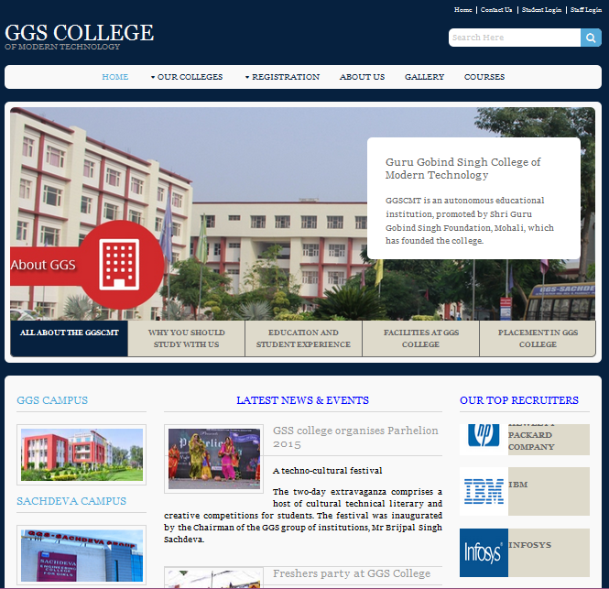

Home Page

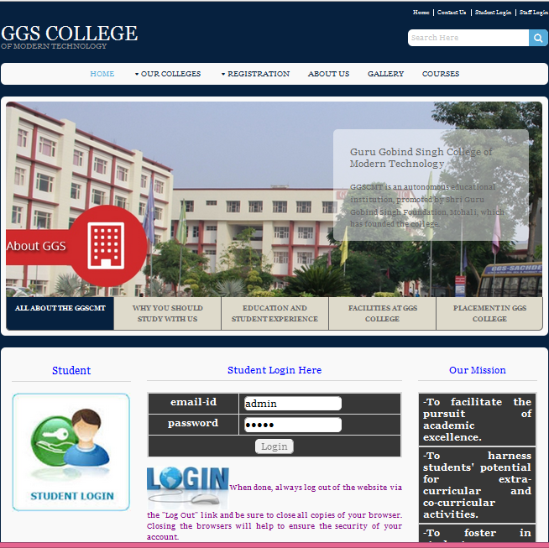Admin Login Page

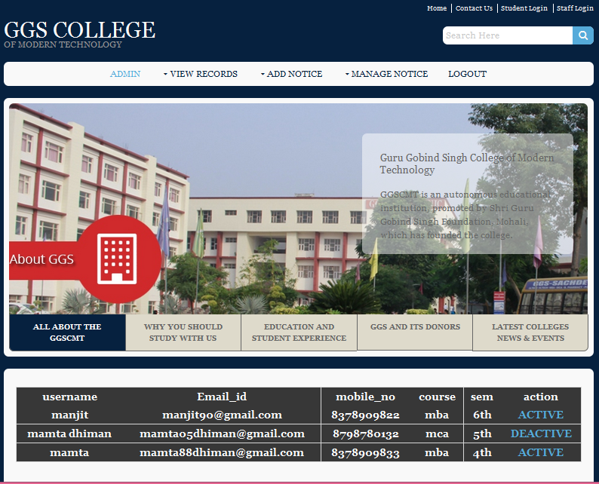Admin Page

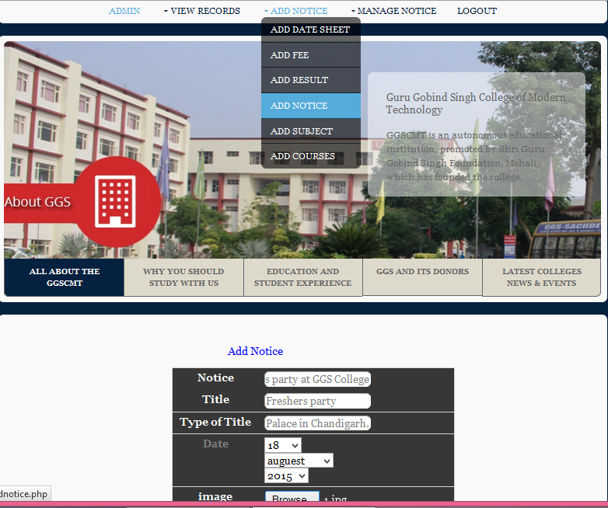Notice Structure Page

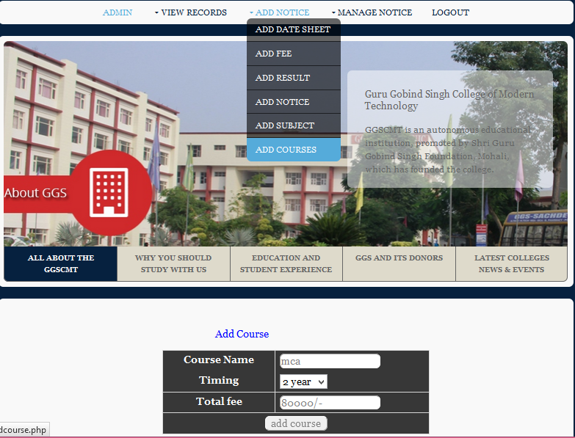Course Structure Page

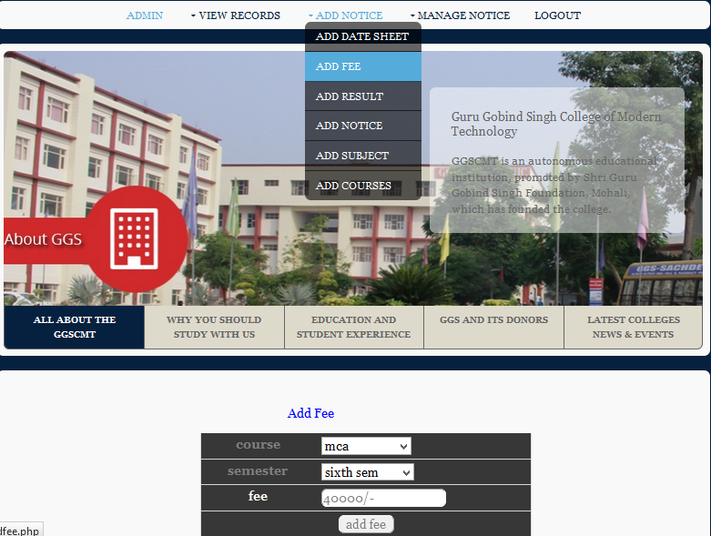

Fee Structure Page

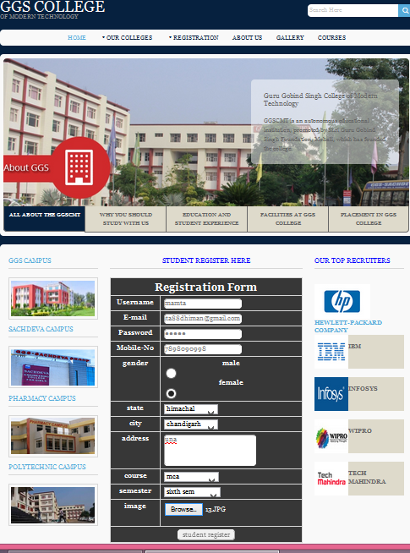Student Registration Form Page

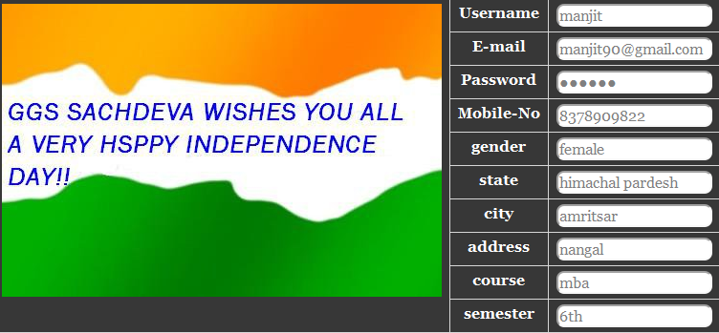Student Page

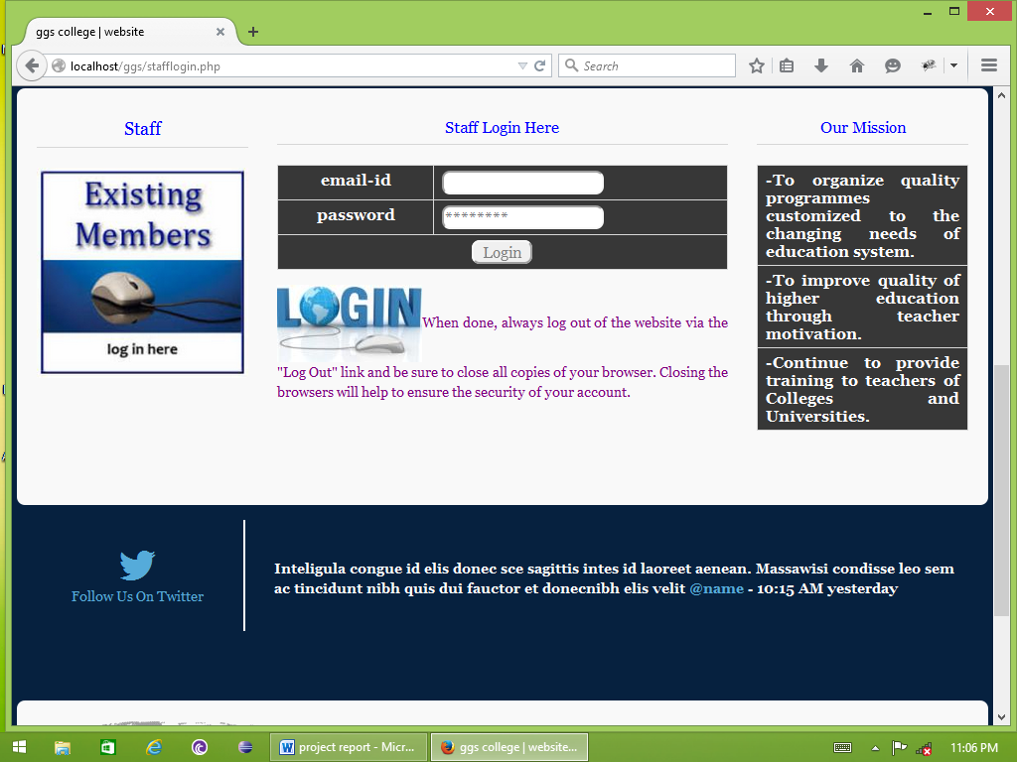

Staff Login Page

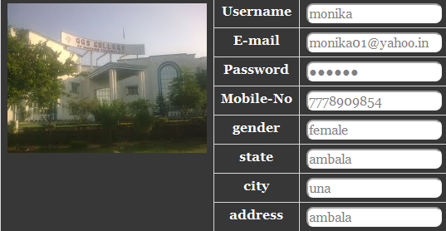

Staff Page

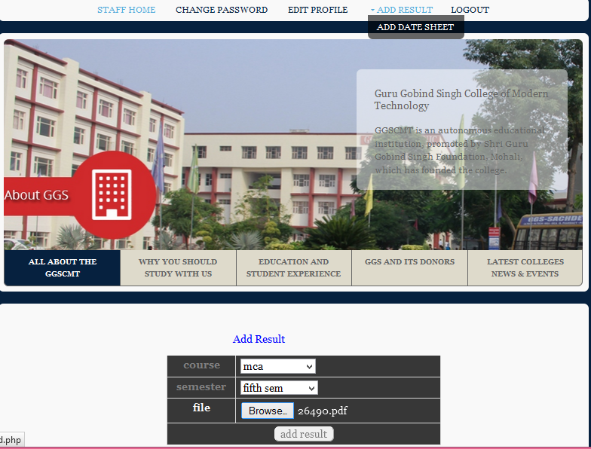Result Structure page

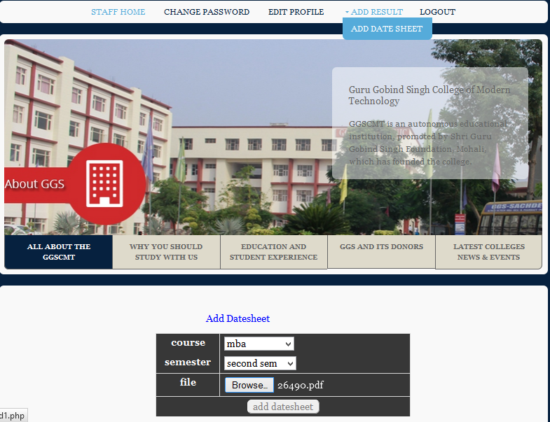Date sheet Structure page

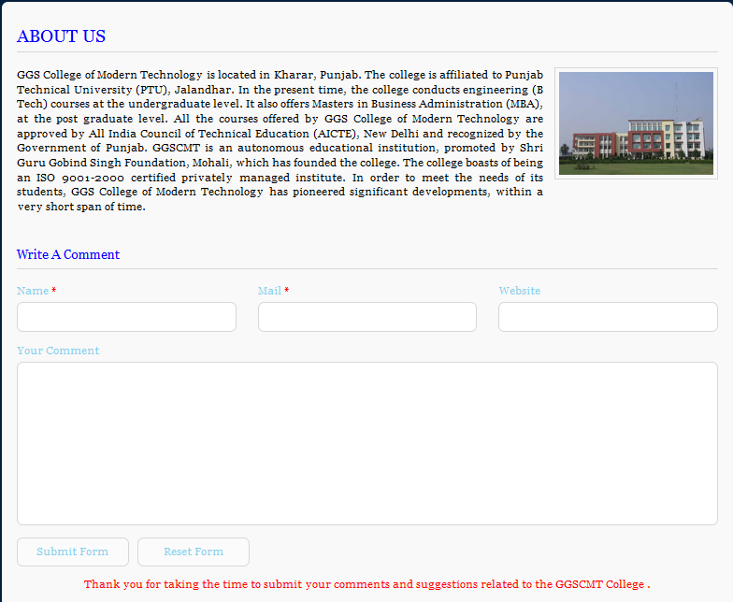About us Page

 Contact us Page

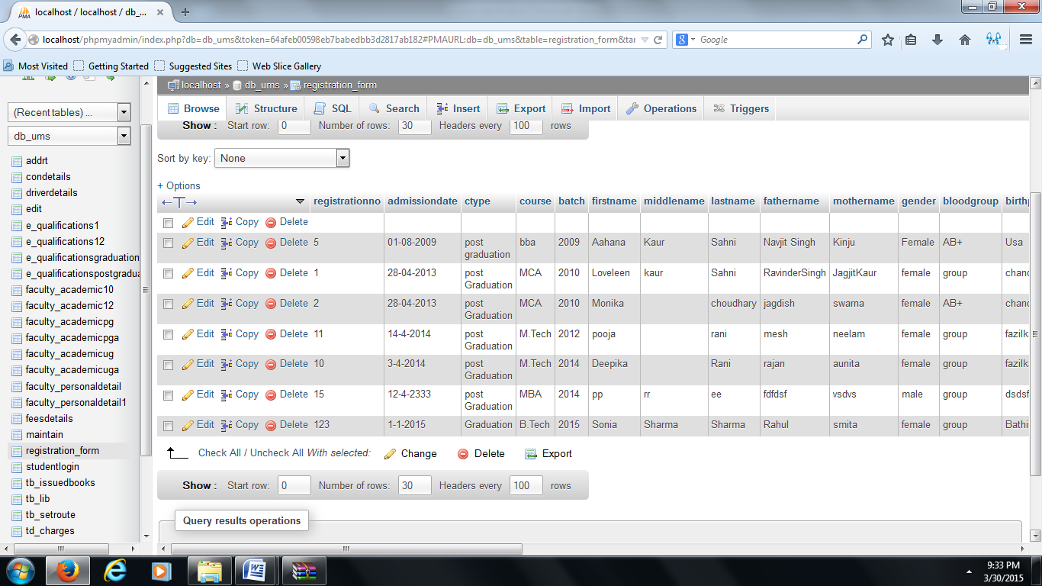Student Register Database Page

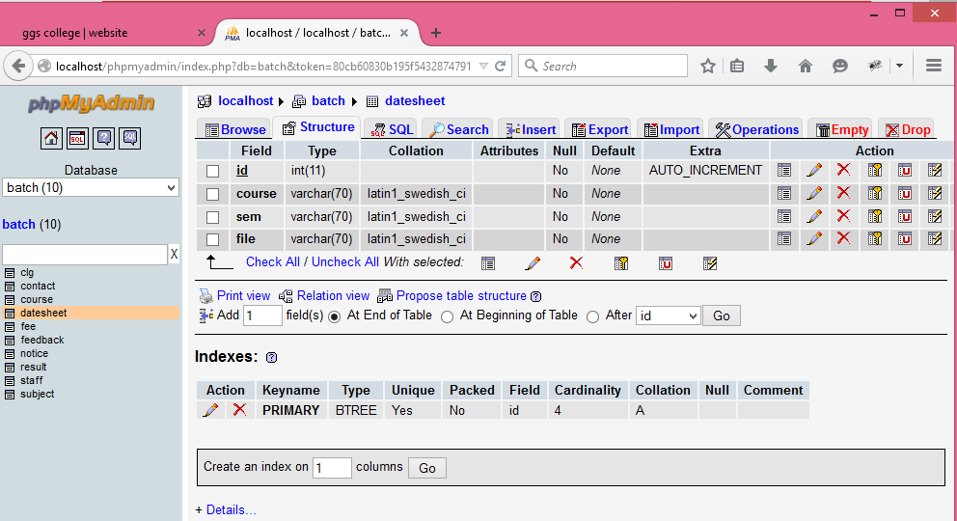Add Date sheet Database

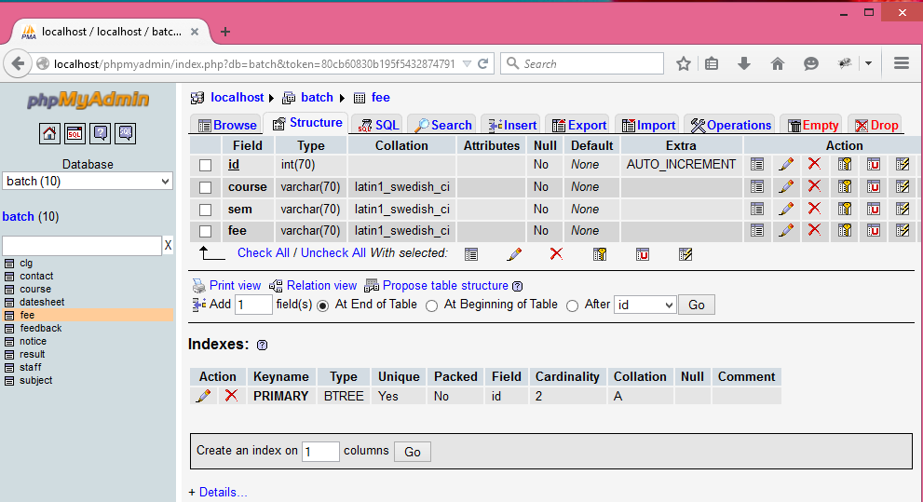Add Date sheet Database

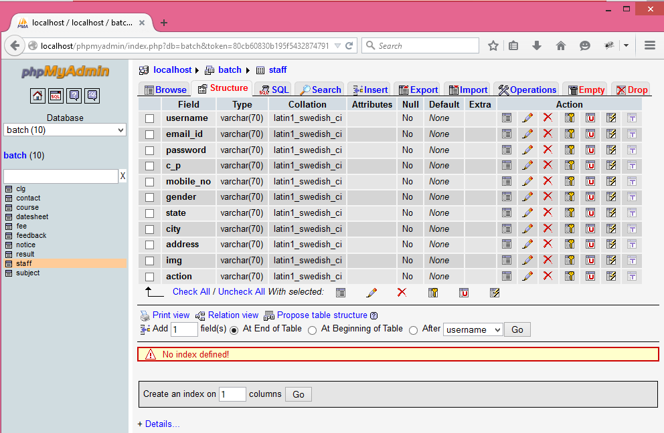Staff Register Database

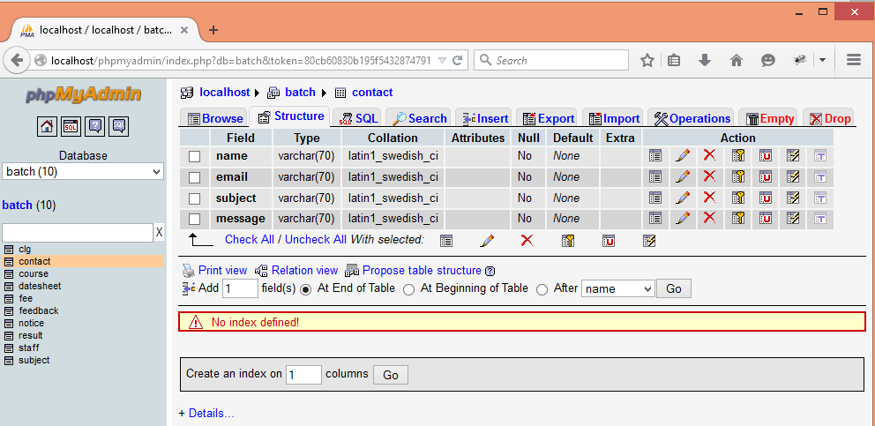Contact Us Database

**Chapter-9**

**IMPLEMENTATION**

**9.1IMPLEMENTATION:**

The implementation phase involves installing approved applications into production environments. Primary tasks include announcing the implementation schedule, training end users, and installing the product. Additionally, organizations should input and verify data, configure and test system and security parameters, and conduct post-implementation reviews. Management should circulate implementation schedules to all affected parties and should notify users of any implementation responsibilities.

After organizations install a product, pre-existing data is manually input or electronically transferred to a new system. Verifying the accuracy of the input data and security configurations is a critical part of the implementation process. Organizations often run a new system in parallel with an old system until they verify the accuracy and reliability of the new system. Employees should document any programming, procedural, or configuration changes made during the verification process.

**For implementation of the website project**:

1. The website can be installed on a computer or a server which has PHP and MYSQL installed in it.
2. The owners of the website are to be properly trained to use all the features of the website, giving details of each features of the website.
3. To show the accuracy of the website and conformance of the website to the requirements of the owners or users of the website.

**Chapter-10**

**MAINTENANCE**

**10.1MAINTENANCE:**

The maintenance phase involves making changes to hardware, software, and documentation to support its operational effectiveness. It includes making changes to improve a system’s performance, correct problems, enhance security, or address user requirements. To ensure modifications do not disrupt operations or degrade a system’s performance or security, organizations should establish appropriate change management standards and procedures.  
Routine changes are not as complex as major modifications and can usually be implemented in the normal course of business. Routine change controls should include procedures for requesting, evaluating, approving, testing, installing, and documenting software modifications.

Maintaining accurate, up-to-date hardware and software inventories is a critical part of all change management processes. Management should carefully document all modifications to ensure accurate system inventories. Management should coordinate all technology related changes through an oversight committee and assign an appropriate party responsibility for administering software patch management programs. Quality assurance, security, audit, regulatory compliance, network, and end-user personnel should be appropriately included in change management processes.

**For maintenance of the website**:

* The database has to be updated regularly according to new available information.
* Redundant and false information must be removed from the database
* Newer version of PHP and MYSQL can be used for up gradation of website and to improve the overall performance of the system.
* Perform backups
* Maintain user administration and access privileges
* Ensure audit logs are available
* Update security software
* Review physical protection
* Review software and hardware warranties.

**For maintenance of the website**:

* The database has to be updated regularly according to new available information.
* Redundant and false information must be removed from the database.
* Newer version of PHP and MYSQL can be used for up gradation of website and to improve the overall performance of the system.

**Chapter-11**

**CONCLUSION**

It has been a great pleasure for me to work on this exciting and challenging project. This project proved good for me as it provided practical knowledge of not only programming in PHP as working of web based application and no some extent Windows Application and WAMP server also about all handling procedure related with “Design and Development of College Website”. It also provides knowledge about the latest technology used in developing web enabled application. This will provide better opportunities and guidance in future in developing projects independently.

This project **“College Website** “is used to provide information about the college.. It can be used by educational institutes or colleges to provide information for the students. This project gives the great control to handle the college or any system in any organization that working as college. Using this website we can simply share all information about our organization to all over the world. This project performs a complete application of modest size that uses PHP, JavaScript and HTML to link a Tutorial with Database (MySQL).

**Chapter-12**

**FUTURE SCOPE**

**Scope:**

* Smooth and effective functioning of College management procedure.
* Any kind of information could be provided to the user.
* Personal and Career information from a broad spectrum of BE, MBA and MCA professionals
* BE, MBA and MCA course and other information from college.
* Timely and up to date information that encourages readers to return to the site.
* Call to action, and plans for students to follow to prepare for a BE, MBA and MCA career.
* The basic problem faced by students is inconvenience of visiting college for each and every requirement viz. fee structure, registration, announcements, bus route is solved.

**Chapter-13**

**BIBLIOGRAPHY**

References for the Project Development were taken from the following Books and Web Sites.

* PHP book by Vasvani (TMH publications).
* Beginning PHP5 by WROX.
* www.google.com.
* www.wikipedia.com
* www.w3schools.com
* Informatics practices by Sumita Arora
* PHP for dream weaver By David Power

.